Worksheet - Smart Contracts for Business - and How to Read One
Week 4, Session 1 | Assessment 2 (A2) - the weekly worksheets | You submit this yourself
Complete it in class and submit it on Moodle before you leave.
Your details (not marked)
Full name | Meqdad Muhana
Student ID | 202306213
Today's partner / group | Ali Mohammed Radhi – 202304871 / Sayed Ali Abbas Mahmood - 202301601
How this worksheet works
• This worksheet counts towards Assessment 2. You complete and submit it yourself, even when you work with others.
• Write your answers in your own words, and list any sources you used in Task 4.
Words to know
These are the words this worksheet uses. You are not marked on the definitions themselves, only on using the ideas.
Term | Plain meaning
Smart contract | A small program stored on a blockchain. It runs by itself once its conditions are met, so an agreement is carried out without anyone having to act.
Off-chain | Kept or done outside the blockchain record, such as a customer's identity documents held in a firm's own files.
Mitigation | A specific action taken to make a risk less likely to happen, or less damaging if it does.
Escrow | Money or an asset held by a neutral party and released only when the agreed conditions have been met.
Tools you need today
Every tool below is free and none of them needs real money. If one will not work, read its last line and carry on. A tool that refuses you is not your mistake.
Etherscan, the Ethereum block explorer
• Where to find it - Etherscan: https://etherscan.io
How to get to what you need:
1. Open the address above in your browser.
2. On the home page, find the list headed Latest Transactions.
3. Click any transaction in that list to open its own page.
4. The fields you need are on that page: From, To, Value, Transaction Fee, Status.
Before you start:
• Nothing. Reading is free and you do not need an account.
If it does not work: If the site is blocked or slow, use the annotated transaction card in this session's Moodle folder and label that instead. It carries the same fields.
Verified contract pages on Etherscan
• Where to find it - Verified contracts: https://etherscan.io/contractsVerified
How to get to what you need:
1. Open the address above, which lists contracts whose code has been published.
2. Or search the name of the protocol you want in the Etherscan search box.
3. On the contract page, open the Contract tab, then Read Contract.
4. The function names you need are listed there. You do not write any code.
Before you start:
• Nothing. Reading a contract is free and needs no account and no wallet.
If it does not work: If the site is blocked, use the annotated contract card in this session's Moodle folder. It lists the same functions.
Task 1 - From the reading
Answer the guiding questions from the structured extract.
Expected: 2-3 sentences per question.
Q1. In plain words, what can a smart contract do that a normal contract cannot?
A smart contract can hold, control, and automatically transfer funds on a blockchain as soon as agreed conditions are met, without relying on human trust or court enforcement. Unlike a traditional paper contract that requires lawyers, manual action, and legal proceedings to settle disputes, a smart contract executes its rules immediately and cannot be stopped by either party once triggered. In addition, the contract code is publicly visible on the blockchain, allowing any business partner to audit and verify how the agreement will run before committing funds.
Q2. What is the oracle problem, and why does it limit business use?
The oracle problem occurs because a blockchain is a closed ledger that cannot fetch outside information, such as market prices, flight statuses, or delivery confirmations, on its own. To run business agreements, smart contracts must rely on external data feeds called oracles to report real-world facts to the chain. This limits commercial use because if an oracle feed is hacked, delayed, or inaccurate, the contract will still execute automatically on that false data, causing permanent financial loss that cannot be reversed.
Q3. For a trade-finance escrow, name one oracle risk and one mitigation.
In a trade-finance escrow, the primary oracle risk is that a shipping tracking feed is manipulated or corrupted to report that cargo has arrived at port, causing the contract to release escrow funds before the goods are actually delivered. Because blockchain transactions are irreversible, the buyer suffers an immediate financial loss with no automatic way to recover the funds. ONE concrete mitigation is requiring multi-source oracle consensus, where the contract releases payment only when three independent logistics and port authority data feeds all confirm delivery.
Task 2 - Apply it (individual build task)
Now use the ideas from Task 1 to do this, in your own words:
For the deployed contract you read on Etherscan, state the off-chain data it depends on (its oracle dependency) and ONE concrete mitigation for that oracle risk.
Expected: 3-5 sentences.
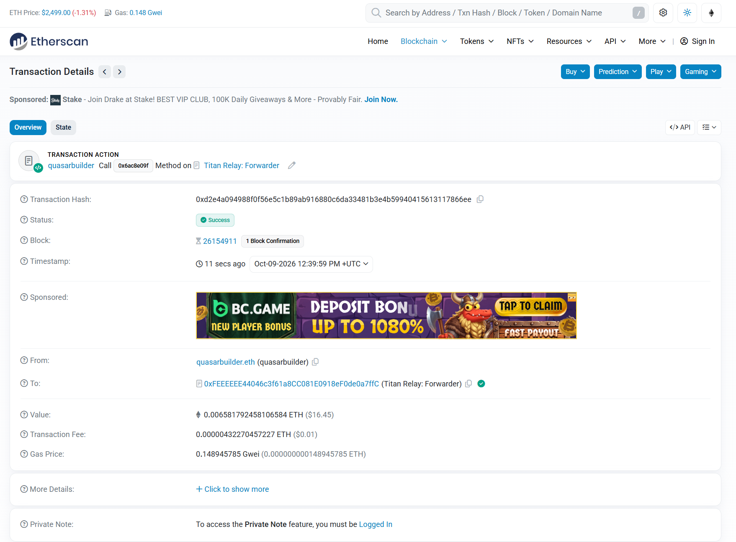
The deployed contract examined on Etherscan, the Titan Relay Forwarder (0xFEEEEEE44046c3f61a8CC081E0918ef0de0a7ffC), depends on off-chain gas price feeds and transaction bundle bids submitted by external block builders. If this incoming fee data is delayed or manipulated, the contract will execute transactions with inaccurate gas payments, resulting in failed execution, wasted funds, or severe front-running risks. ONE concrete mitigation to control this oracle risk is implementing a programmatic circuit breaker directly within the contract code. This circuit breaker automatically checks submitted fee values against an acceptable range and halts execution immediately if an external price figure looks abnormal or exceeds a strict safety ceiling.
Task 3 - Group activity (your own write-up)
Translate a real contract.
Choose two or three people to work with. Together, read a deployed Uniswap or Compound contract on Etherscan and translate it to business language using function names and events; each writes their own.
• Open a deployed contract on Etherscan and list its main functions.
• Translate what it does into plain business-process language.
• Identify any off-chain data it relies on (the oracle dependency).
• State one mitigation for that oracle risk.
Expected: complete the activity above, then write your own answer of about half a page.
Write your own answer here:
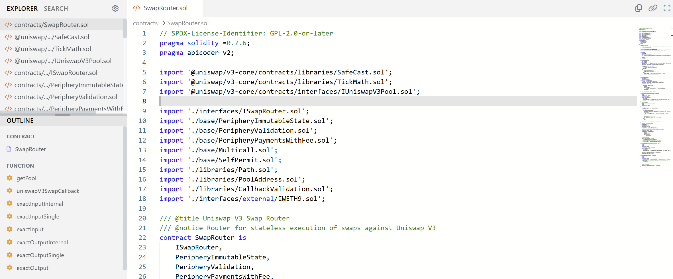
Examining the deployed Uniswap V3 SwapRouter contract (0xE592427A0AEce92De3Edee1F18E0157C05861564) on Etherscan reveals four primary commercial functions and logged events that automate cryptocurrency trading. For a business executive, these operations translate directly into standard financial processes:
- exactInputSingle (Spot Currency Exchange): A company provides an exact amount of one digital currency to purchase another currency in a single trading pool. The contract automatically calculates the prevailing exchange rate and delivers the maximum possible amount of the desired asset immediately.
- exactInput (Multi-Hop Payment Routing): When a direct trading market does not exist between two currencies, this function acts as an automated multi-currency cross-border settlement. It routes the sale through intermediate asset pools in a single transaction to deliver the required target currency at the best available rate.
- exactOutputSingle (Exact Invoice Settlement): A business specifies the exact quantity of an asset needed to pay a supplier invoice. The contract automatically calculates and deducts only the necessary amount of the initial token required to settle that exact bill, returning any excess funds to the firm.
- exactOutput (Multi-Hop Purchase Order Settlement): Similar to a complex international procurement order, this function routes through multiple currency pairs to guarantee that a vendor receives an exact payment total, shielding the transaction from routing miscalculations.
Events (Audit Trail):
When any trade completes, the contract writes out a Swap event to the blockchain log. In business terms, this event serves as an unalterable, automated transaction receipt that records the exact timestamps, sender address, amounts traded, and final fee paid for internal accounting and regulatory audits.
Oracle Dependency and Mitigation:
The contract relies on real-time off-chain market price data to determine fair exchange ratios between assets. If this outside pricing data is delayed or manipulated by a predatory trader, the contract will execute trades at artificial rates, draining pool liquidity. ONE concrete mitigation is using a Time-Weighted Average Price (TWAP) oracle, which calculates prices across a rolling historical window rather than a single instant snapshot, making price manipulation unfeasible.
Task 4 - Sources
Sources I used (if any) | Bahrain Polytechnic. (2026). IT8204 Week 4 Session 1: Structured Extract, Visual Reading, Contract Card, and Opener Slides. School of Information and Communication Technology.  Central Bank of Bahrain. (2019). CBB Rulebook, Volume 6: Capital Markets, Module CRA (Crypto-Asset). Manama: Central Bank of Bahrain.  Drescher, D. (2026). Blockchain basics: A non-technical introduction in 25 steps + 5 steps beyond the basics (2nd ed.), Steps 27–28. Apress / Springer Nature.  Etherscan. (2026). Ethereum Blockchain Explorer: Titan Relay Forwarder Contract (0xFEEEEEE44046c3f61a8CC081E0918ef0de0a7ffC) and Transaction 0xd2e4a094988f0f56e5c1b89ab916880c6da33481b3e4b59940415613117866ee, from Ethereum Transaction Hash: 0xd2e4a09498... | Etherscan  Etherscan. (2026). Ethereum Blockchain Explorer: Uniswap V3 SwapRouter Contract (0xE592427A0AEce92De3Edee1F18E0157C05861564).  Uniswap Labs. (2026). Uniswap V3 Technical Whitepaper & Core SwapRouter Documentation.
Before you submit
• Your name and student ID are filled in.
• All tasks are attempted.
• Submit this sheet before you leave today, to the Week 4 weekly worksheets link on Moodle. That same link takes both of the Week 4 weekly worksheets, one per session.
• If you need more time, finish it at home and submit to the same link by Friday 9 October 2026, 23:59. That is the deadline for both Week 4 sheets.
• Both weekly worksheets are marked together in one Week 4 marking sheet worth 2.50 percent of the course.
• You may use your notes and the session readings. Every worksheet is your own work.

